# *TRACING THE GROWTH OF THE GLOBAL COMMUNITY : A POPULATION FORECASTING ANASLYSIS*

# 

# Population Forecasting for Water Supply System - The Constructor

Miniproject On

Tracing the growth of the global community: A population forecasting analysis

**BACHELOR OF SCIENCE**

**IN**

**MATHEMATICS**

**BY**

* + - * + **S.Anitha**
        + **B.Gayathri**
        + **K.Karpagam**
        + **M.Malaiyarasi**
        + **S.Vijayalakshmi**



ARUMUGHA PALAMIGURU ARTS AND SCIENCE COLLEGE FOR WOMEN CHATRAPATTI,

RAJAPALAYAM

Affiliated to Madurai Kamaraj University

Rajapalayam

Tracing the growth of global community:A population forecasting analysis

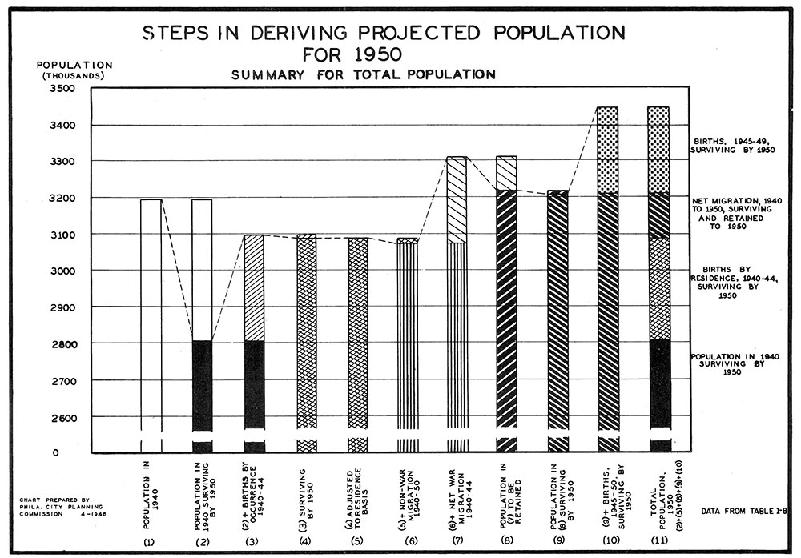

1.INTRODUCTION:

1.1 Overview

The world's population is more than three times larger than it was in the mid-twentieth century. The global human population reached 8.0 billion in mid-November 2022 from an estimated 2.5 billion people in 1950, adding 1 billion people since 2010 and 2 billion since 1998.

Basically, there are three techniques for population projection: Mathematical Method, Economic Method and Cohort Component Method. Mathematical method is frequently used for the estimation of population. It is done for short period i.e. less than 10 years

PURPOSE:

In this project we are trying to analysis the population forecasting analysis

2.PROBLEM DEFINITION AND DESIGN MAPPING

# *2.1EMPATHY MAP:*

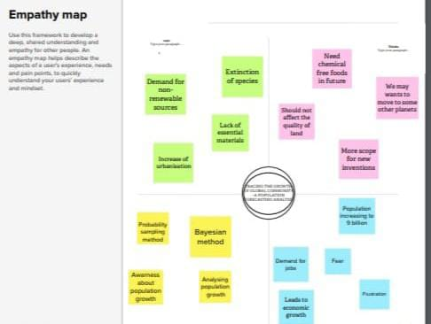

*2.2 Ideation &Brainstroming Map:*

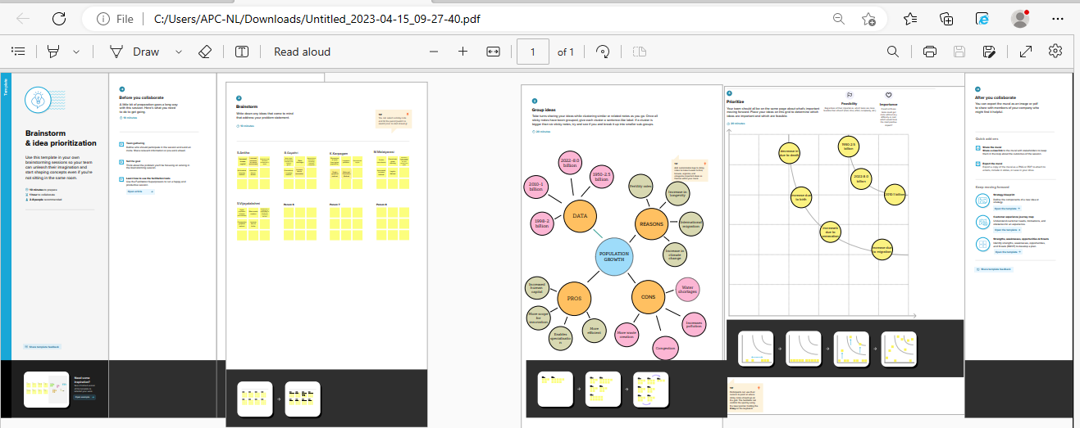

# *DASHBOARDC:\Users\ELCOT\Pictures\Screenshots\Screenshot (40).png*

# *STORY*

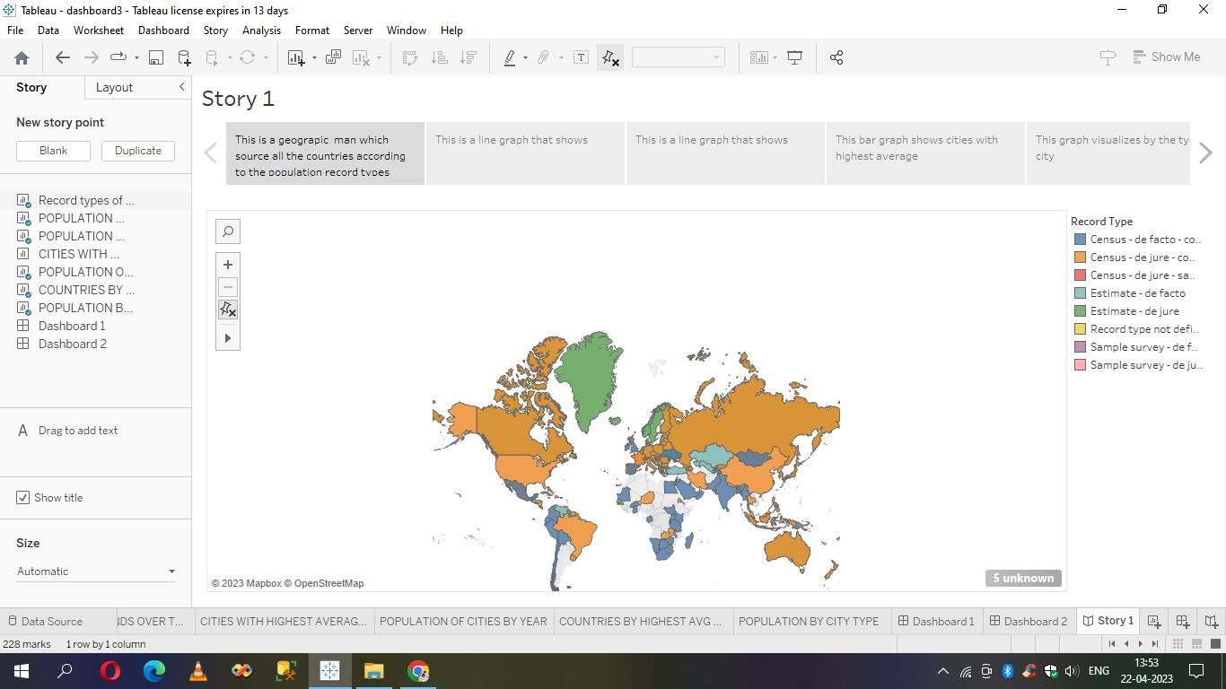

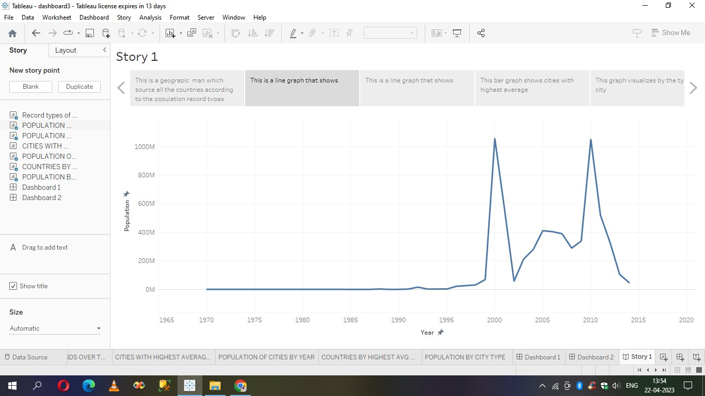

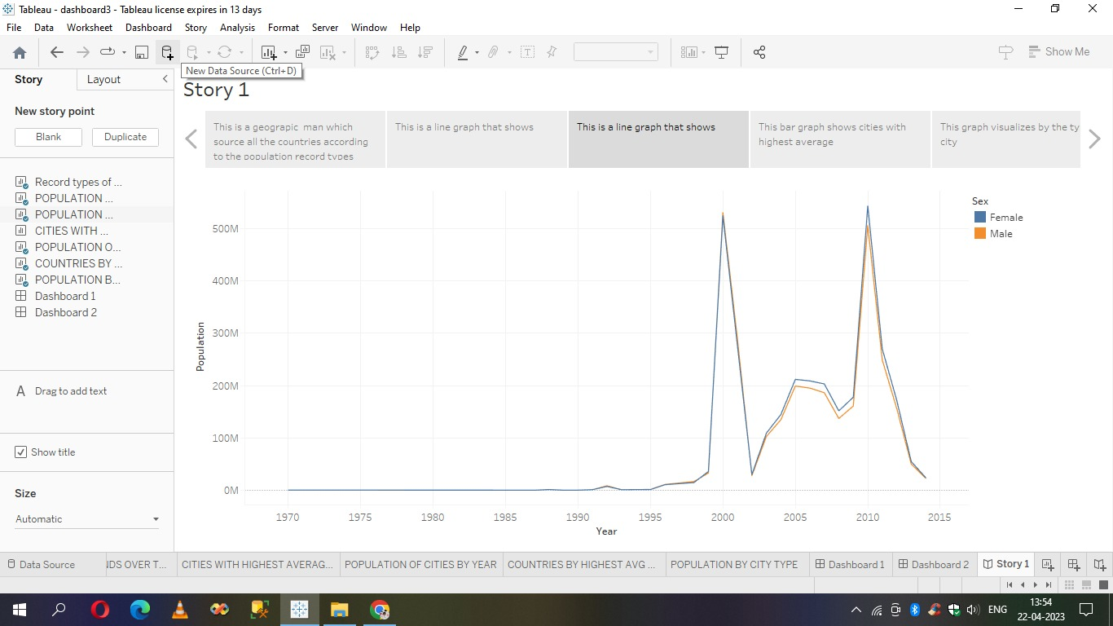

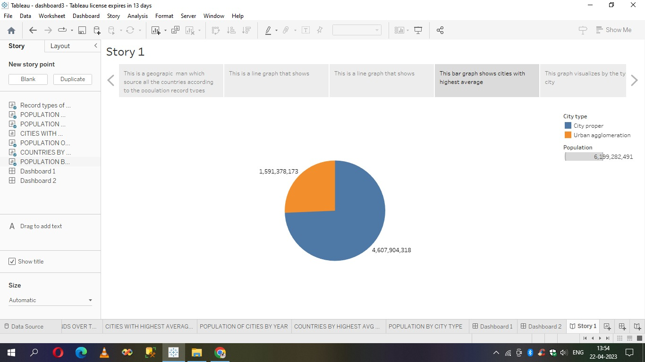

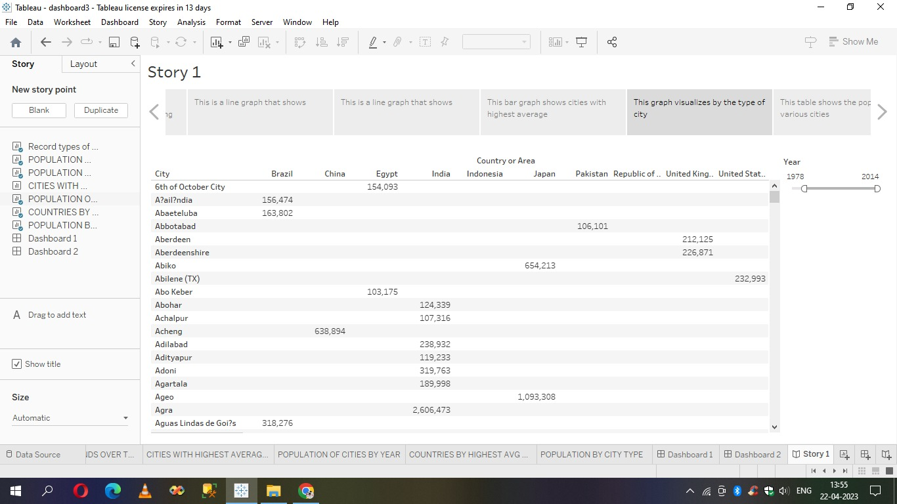

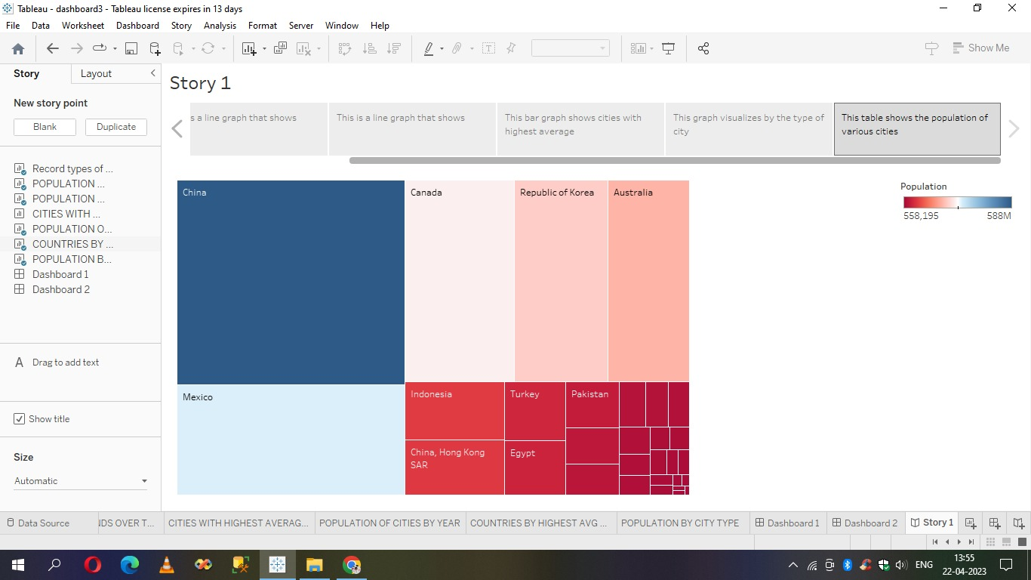

# *ABOUT*

The Journal of Environment & Development (JED) offers policy-makers, non-governmental organizations, scientists, academics, and the business community the only international forum that combines cutting edge academic research with practical analysis of working policies. The broad scope and interdisciplinary nature of The Journal of Environment & Development are demonstrated by the wide variety of interests and disciplines of its readers and contributors, which include political science, international relations, economics, development studies, sociology, environmental studies and law. The Journal of Environment & Development seeks to further research and debate on the nexus of environment and development issues at the local, national, regional, and international levels. The journal provides a forum that bridges the parallel debates among policy makers, attorneys, academics, business people, and NGO activists from all regions of the world. This journal is a member of the Committee on Publication Ethics (COPE).

# *TEAM MEMBERS*

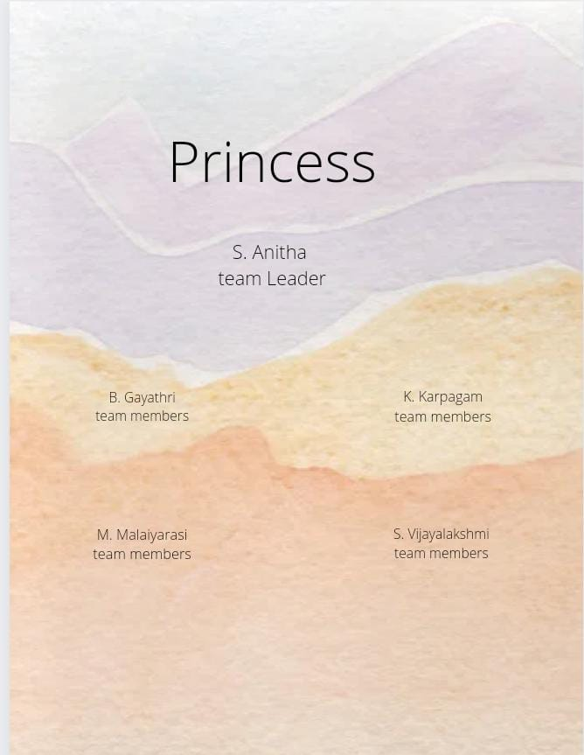

# *ADVANTAGES AND DISADVANTAGES*

### Advantages of population growth

**1. More people leads to greater human capital**. If there are more people, the probability of finding a genius like Einsterin, Marie Curie, Beethoven increase. These exceptional people can lead to technological and cultural masterpieces which enrich our lives. The past 200 years have shown exponential growth in technical development and innovation. There are many factors behind this, but the world’s growing population means we have a bigger pool of human capital and the possibility of these cutting edge discoveries increase.

**2. Higher economic growth**. Population growth will lead to economic growth with more people able to produce more goods. It will lead to higher tax revenues which can be spent on public goods, such as health care and environmental projects.

* The obvious evaluation is to say, the crucial thing is not GDP, but [GDP per capita](https://www.economicshelp.org/blog/glossary/real-gdp-capita/). If economic growth is at the same rate as population growth, average living standards will not increase. However, it is possible population growth can also improve per capita incomes. As the population increases, the economy can benefit from a bigger talent pool, economies of scale and greater specialisation. All this can enable higher per capita income, which we have seen in major developed economies.

### Disadvantages of population growth

**1. Cost to the environment.** Population growth exacerbates many of the existing environmental problems

* Trying to reduce carbon and methane emissions to reduce global warming is relatively more difficult as the population.
* There will be greater threat on natural habitats as a greater population has greater demand for housing and farmland. This will increase pressure to cut down forests to make way for farming and housing.
* Higher population will lead to a greater consumption of non-renewable resources, leading to a faster depletion of natural resources.
* Higher population will lead to greater pollution levels in air, water and land. Higher pollution is associated with a range of health issues, such as cancer and asthma. The pollution also harms animals and plants.
* Soil degradation. To feed a growing planet, we have seen serious degrading of farmland (according to UN estimates) about 12 million hectares of farmland every year. This is due to factors, such as overgrazing, use of chemicals, climate change and use of chemicals

# *CONCLUSION:*

The global community is important because it brings together people from all over the world who share common values and beliefs. Since we share one planet and one future, we have a responsibility to each other, no matter where we live or how different our cultures are global community.

# APPENDIXC:\Users\ELCOT\Downloads\WhatsApp Image 2023-04-24 at 1.46.10 AM.jpeg









# *THANK YOU*